Worksheet for comprehension passage

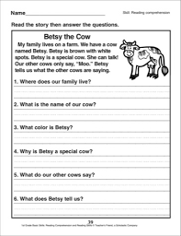

**Follow on activity: If you were Betty the cow, what would you say to the other cows. Write what you would say.**